**7. PROPOSED SYSTEM AND ITS OBJECTIVES**

**7.1 Introduction**

The project titled Library Management System is Library management software for monitoring and controlling the transactions in a library.The project “Library Management System” is developed in java,which mainly focused on basic operations in a library like adding new member,new member,new books,and updating new information,searching books and facility to borrow and return book.

“Library Management Notification System” is a windows application written for 32-bit windows operating systems,designed to help users maintain and organize library.our software is easy to use for both beginners and advanced users.it features a familiar and well thought-out an attractive user interface,combined with strong searching insertion and reporting capabilities.The report generation facility of library system helps to get a good idea of which are the books borrowed by the members,makes users possible to generate report’s hard copy.

The software Library Management Notification System has four main modules

* Insertion to Database Module-user friendly input screen
* Extracting from Database module-Attractive output screen
* Report Generation module-borrowed book list&Available book list
* Search Facility system-search for books and members

**7.2 Existing system Vs Proposed system**

Existing system does not have any facility of teachers login or student login where as proposed system will have a facility of student login as well as teacher’s login ii. Existing system does not have a facility of online reservation of books whereas proposed system has a facility of online reservation of books iii. Existing system does not have any facility of online notice board where description of workshops happening in our college as well as nearby colleges is being provided. iv. Existing system does not has any option of lectures notes uploaded by teachers whereas proposed system will have this facility v. Existing system does not have any facility to generate student reports as well book issue reports whereas proposed system provides librarian with a tool to generate reports vi. Existing system does not has any facility for book request and sugeestions where as in proposed system after logging in to their accounts student can request books as well as provide suggestions to improve library

**7.4 Objective**

* To record the book’s details.
* To record the member’s details.
* Reliable as information is stored logically than physically than physically.
* Faster search of available books and members than by hand.
* It saves time for the management of library.

**7.5 Modules**

1.Books:- This sheet stores all the relevant information about the books which includes *Book ID, Title, Author, Publisher, Category, Year, ISBN, Edition, Date Purchased, Price and Shelf No.*

* *Book ID* is automatically generated whenever a new book is entered. It is based on last two digits of year, last two digits of ISBN and the last four digits assign a number starting from 1 based on the order entering the books into system.



2.Issue:- This sheet has a record of all the books issued since the system was implemented. It includes *Issue Code, Book ID, Student ID, Category, Issue Date, Due Date*and*Class*.

Issue code is VBA generated field which is used to identify which book has been issued by which student at which date. It last two digits of *BookID*, last two digits of *StudentID* and excel date code of issue date. Same student may issue one book more than once. This would create a problem in calculating how much fine to charge. To overcome this problem, date code of issue date has been added to issue code to make each issue code unique. This will be used in vlookup to calculate fines when return date exceeds due date.

Due date is within two weeks of issue date.

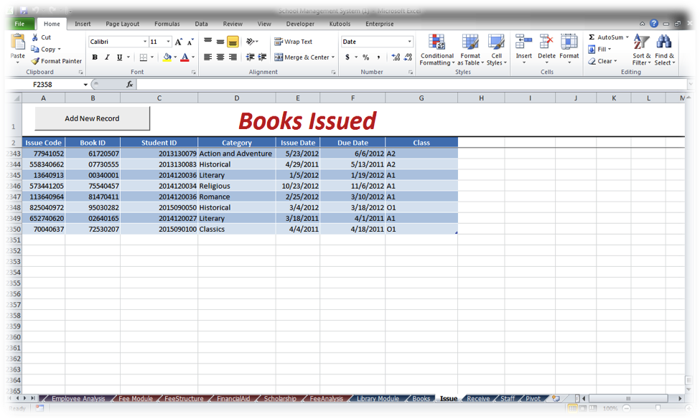

#### 3. Receive:-

* + This sheet keeps a record of books received by library. It includes Issue Code, Book ID, Return Date, Received By, Condition, Damaged %, Fine (Rs) and Student ID fields.
  + Book damages are determined by Library staff and the percentage of book damaged is multiplied by the price of book from books table to calculate damages.
    - Fines are charged at Rs. 10 per day after due date. Net fine is total of late charges and damages.
  + StudentID shown here is looked us from book issue table. This is used to get information about the students which have returned the books.

#### 4.Staff:-

The staff table shows brief details of people employees by the library. It includes name of employee, designation and shift. The system requires the person receiving books to mention his/her name.

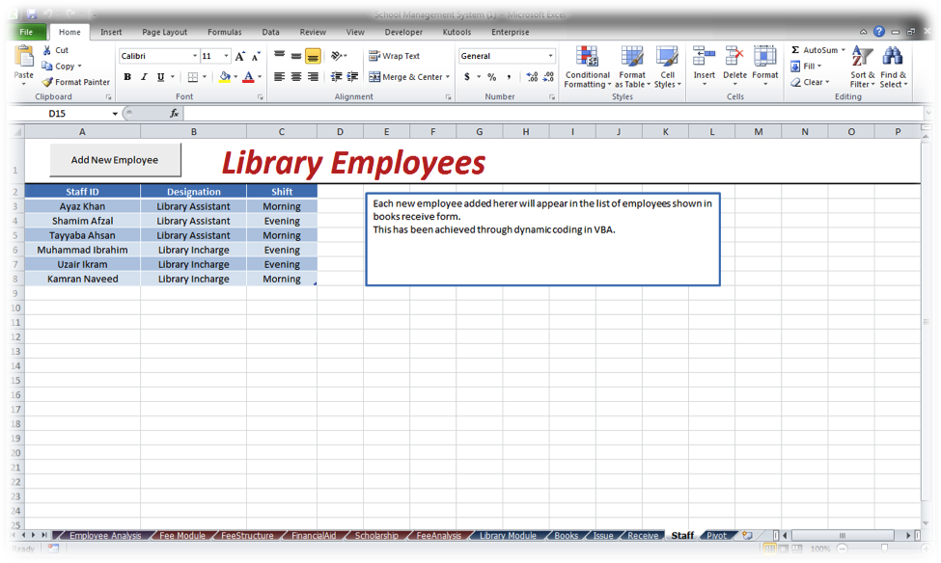

### 5.Forms for Data Entry:-

 All the forms have a “Clear Form” button to easily erase all the data from fields to input new one.

#### 6.Add Book :

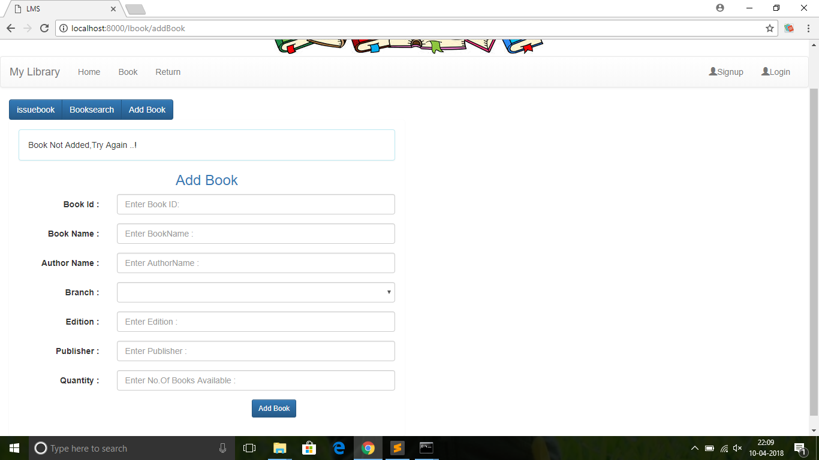

#### 7.Books Issued:

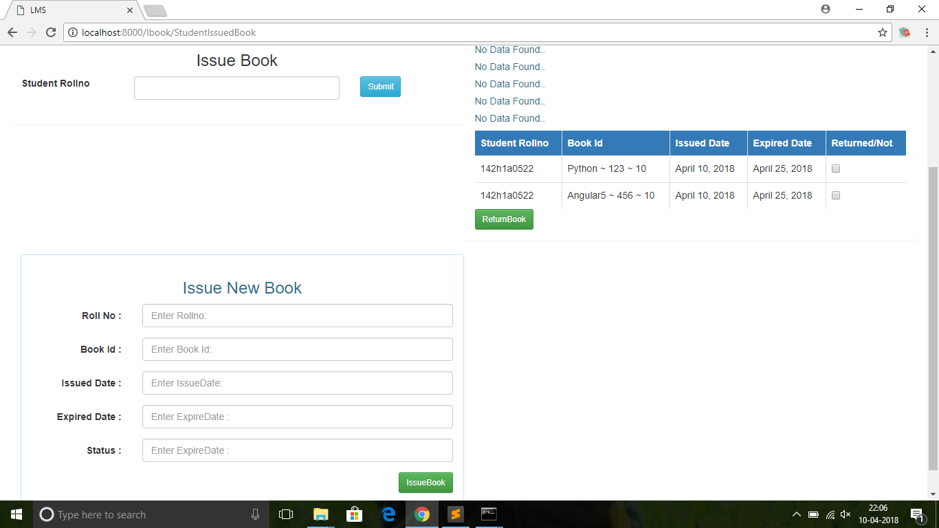

#### 8.Books Received:

The list under received by heading is shown using data from staff sheet. This is a **dynamic** **list** and is updated automatically whenever new employee is entered in library staff sheet. There is no need to enter names manually in VBA codes.



#### 9.Library Staff:

### 10.Charts & Analysis for Library Management Module:

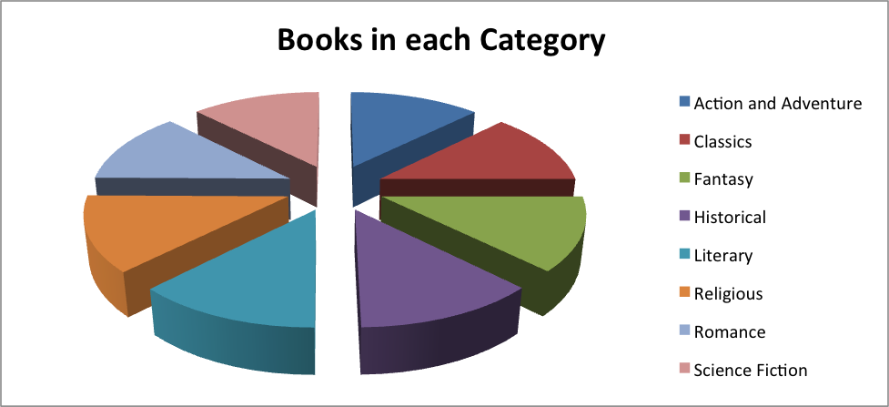

The above chart is made from pivot table data from Books sheet. Due to using random function in excel, one can see that distribution is fairly equal.

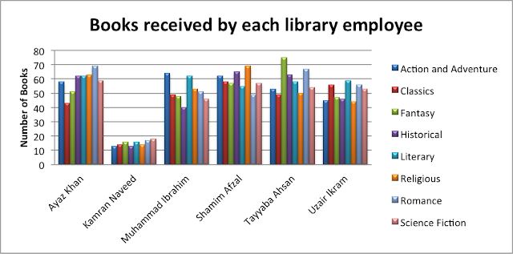

Bar chart showing books received by each employee

This table shows data of books each employee received. This has been created through pivot table data from “Books” sheet.

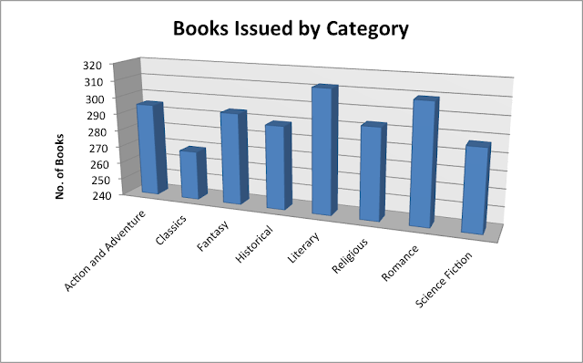

This chart shows the books issued by category. It has also been created through pivot table data from “Books” sheet. It shows which category is most popular amongst students.

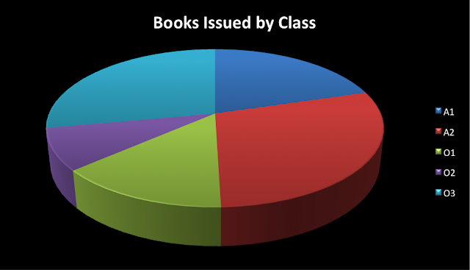

Pie chart showing books issued

This chart shows the books issued to students from each class. It can be used to predict demand for books from each class and library book purchases can be done accordingly. This has been created though data from “Receive” sheet.

The module also has a pivot chart for fines charged to each student. These fines are then used in Fee Management module to calculate fee bills.